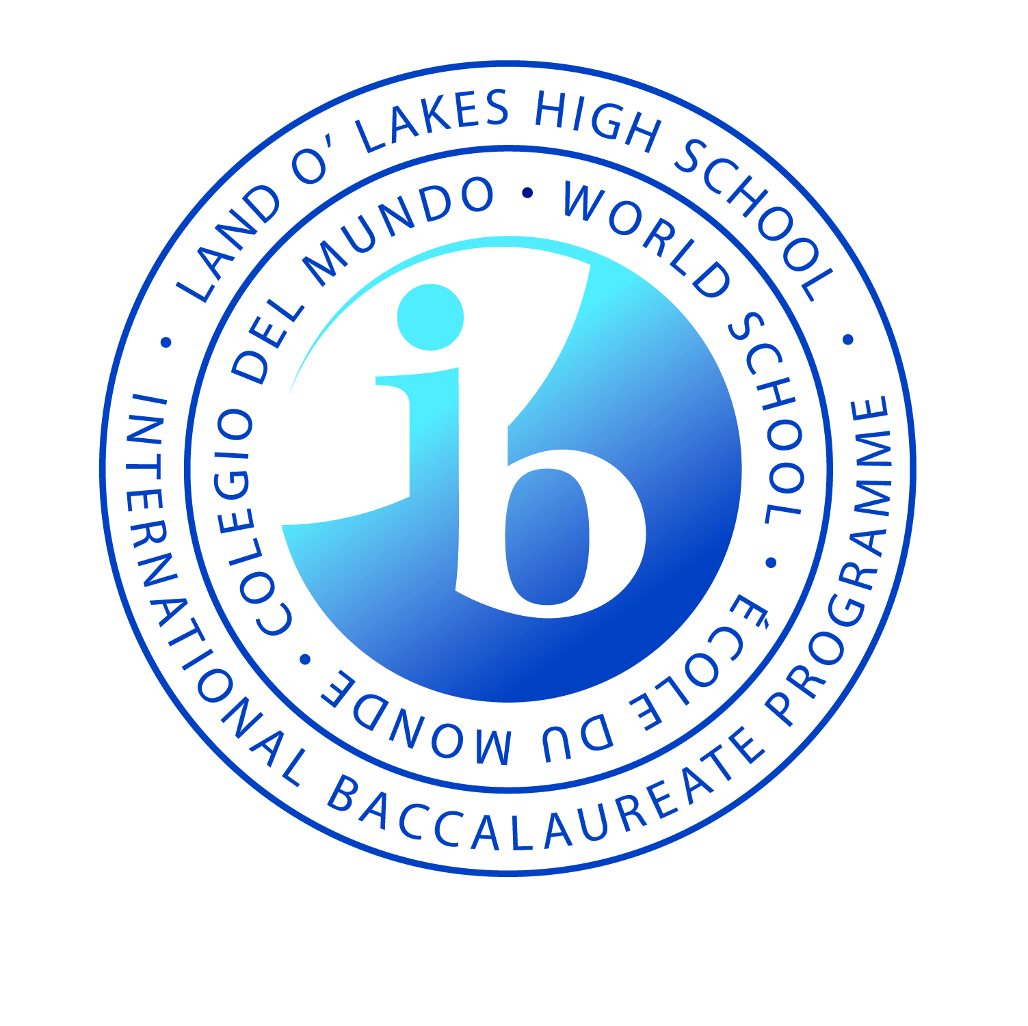
Land O’ Lakes High School
International Baccalaureate Diploma Programme
Language Policy

In keeping with the goals of the IB Mission Statement, the Land O’ Lakes High School International Baccalaureate Diploma Programme institutes this Language Policy.

“The International Baccalaureate aims to develop inquiring, knowledgeable and caring young people who help to create a better and more peaceful world through intercultural understanding and respect.”

Language – Philosophical Principles

- Language diversity, understanding, and production are keys to developing in learners a well-founded sense of international-mindedness.
- Study of one’s heritage language and subsequent ones provides a mechanism to increase international-mindedness. “International mindedness can be expressed as: the ability to be better prepared for the 21st century global challenges; understanding ourselves to connect with others; awareness that the world is much larger than the community in which we live; respect and understanding for other perspectives, cultures and languages; the ability to see oneself as a responsible member of the community and a global citizen” (Source: Jaya Bhavnani, Enhancing International Mindedness, IB Conference of the Americas, July 2013).
- Through understanding others, negotiating meaning in communications, and viewing verbal and non-verbal interactions through a culturally-informed lens, IB students attain readiness to see that, “other people, with their differences, can also be right” (Source: IB Mission Statement).
- The IB Learner Profile contains core attributes that emphasize respect for language and culture. As Communicators, Open-Minded and Caring learners, IB students and staff at Land O’ Lakes High School promote a language- and culture-inclusive environment to, “help individuals and groups become responsible members of local, national and global communities” (IBO, 2013).

Language of Communication

- In order to communicate within the school and with student households, Land O’ Lakes High School shall maintain several modes of interaction: myPascoConnect application dashboard; district and school webpages; myStudent information system; myLearning blended coursework and resource repository; auto-dialer telephoning system; email communications system; print resources; and on-site presentations. All resources have English as their principal language. Online resources that are web-based can be toggled to other languages where hosting the Google Translate toolbar.
- IB Core (CAS, TOK, EE) elements are housed in ManageBac. Each DP student shall receive student access and a corresponding parent/guardian log in to view the student account. ManageBac is set to English and is a web-based or app accessible resource.
- As per Florida Statute, where feasible, essential communication in a family’s heritage language is provided. Largely, this is Spanish, though some communications are produced in other highly represented languages.

Language of Instruction and Assessment – Groups 1, 3, 4, 5, 6

- The language of instruction and assessment for Group 1, 3, 4, 5, and 6 subjects is English. Students are registered as such at the start of each session on IBIS.
- Textbooks and other instructional materials shall be provided in English. If publishers provide language support resources in other languages, teachers will make these available to those students who may need these. This may be viewed as a means to enhancing the student’s use of the family’s heritage language. However, the goal shall be for the student to build the capacity to learn and produce demonstrations of learning in English.

Language Acquisition – Group 2

- Currently, the Group 2 Language B for the Land O’ Lakes High School International Baccalaureate Diploma Programme is Spanish and French.
- The school recognizes the importance of choice in language acquisition, and is committed to providing multiple pathways for students.
- IB students shall study a Group 2 Language B for two years in the diploma years preceded by two years of the same language in the feeder program.
- Students who have studied Spanish prior to entering Land O’ Lakes High School will be placed into a course commensurate with their proficiency level.
- Students who complete four consecutive years of high school Spanish shall be registered for Spanish B SL or HL in the second diploma year, depending on their level of proficiency.
- Students who complete four consecutive years of high school French shall be registered for French B SL in the second diploma year. In subsequent years, students will have the opportunity to register for either French B SL or HL, depending on their level of proficiency.
- In all cases of deciding between SL and HL, the students and teachers will confer regarding recommendation.
- In rare instances, students unable to have sufficient years of study in our Language B offerings will be registered for Language B ab initio. Examples of this are when a student enters first diploma year having never studied one of our world languages. No student who has articulated through to the Diploma Programme from the feeder program shall be registered for Language B ab initio.

English Language Arts State Assessment and Florida Graduation Requirements

- In order to meet Florida graduation requirements, students shall be assessed in English Language Arts and must earn a passing score, which is determined by the state.
- English Language Arts teachers receive in-services, workshops, and presentations each year to assist them with providing learning experiences that lend to students attaining the necessary achievement levels and beyond.
- IB students not meeting the proficiency level for passing the English Language Arts state assessment shall be afforded additional support through their language arts classes. Students will have additional opportunities to sit for the examination until earning a passing score, or may demonstrate proficiency by earning a concordant/comparative score on a state-approved instrument (e.g., ACT; SAT).

Support for English Learners – Non-heritage English speakers

- In a manner emphasizing value for IB Learner Profile attributes, the linguistic and cultural heritage of all students and staff shall be respected.
- Students whose heritage language is other than English or whose level of English language proficiency is less than fluent shall receive equal access to the various curricular programs offered in Pasco County Schools. These include gifted and IB, among others.
- English language proficiency shall not be a barrier to admission to the Land O’ Lakes High School International Baccalaureate Diploma Programme.
- The school seeks to expand participation by students of linguistic and cultural diversity and support their ability to attain high achievement levels leading to earning the IB Diploma.
- While English is the language of instruction (along with Spanish or French in Group 2), Land O’ Lakes High School recognizes the important funds of knowledge brought by students and families from diverse cultures and as members of immigrant groups.
- For students who are designated “LY,” English Learners, the school shall provide support services as required by State Statute and the board-approved Pasco County Schools English Language Learner Plan. As such, students shall be afforded the services that help them be successful learning English as a means towards attaining academic success.
- Pasco County Schools’ ESOL services may be referenced HERE and include:
  - ESOL-trained classroom teachers who give instruction to students in a way to help them understand. These teachers participate in special training workshops that address appropriate strategies and accommodations for increasing English language development and proficiency, as well as content understanding
  - ESOL Bilingual Instructional Assistants who support students and teachers at schools. IAs use the students’ heritage language to help them to learn in the classroom.
  - Compliance Resource Teachers who identify students eligible for ESOL services and keep schools in compliance with state and federal laws.
  - ESOL Instructional Trainer Coaches who monitor students, advise and coach administrators, teachers, and ESOL instructional assistants, and keep schools in compliance with state and federal laws.
  - A district translator/interpreter.

Support for Language Production/Reception Challenges – Inclusive Practices

- In keeping with the Individuals with Disabilities Education Act (IDEA), Exceptional Student Education Services (ESE) shall be provided to students with documented learning exceptionalities and learning support requirements of various types. Relevant to this Language Policy, these include exceptionalities that affect language production and/or reception. Examples include but are not limited to: auditory processing; oral production; hearing loss; dyslexia; dysgraphia; etc.
- The Individual Education Plan (IEP) shall direct where accommodations are necessary to support the student’s ability to participate in learning and demonstrations of learning. This plan can be revisited in a meeting led by the ESE Case Manager.
- Relevant to this Language Policy, teachers shall afford the language accommodations in classroom instruction and assessment, where indicated.
- The IB Coordinator and IB School Counselor shall review the accommodations for applying to The IB for inclusive assessment arrangements, where needed, as directed by the Handbook of Procedures and Candidates with assessment access requirements.

