Land O’ Lakes High School is excited to offer a Virtual Orientation on Tuesday, August 6 from 8am to 2pm. This option has been designed for families to follow the 3 P’s: PAY school fees, PREVIEW student schedules and PRINT student schedules and ACORN receipt. We hope that this provides a convenient option for families outside of the normal face-to-face event.

This virtual option will be accessible for students and families starting at 8am on Tuesday, August 6 via the myStudent platform. Schedules will only be visible on August 6 from 8am to 2pm. Students must have an account through the online portal, myStudent to be able to view and print their schedule. LOLHS will not have personnel available on August 6 to assist you with this process if you have an issue, so try early in case you encounter a problem.

Families may PAY, PREVIEW & PRINT from home and then are invited to attend Open House at LOLHS from 3pm-5pm. Students are welcome to come walk your schedule and meet your teachers. In addition, you will be able to buy Gators gear, get information about activities and athletics, buy PE uniforms, or obtain bus information. Emergency Contact Cards will go home with students on the first day of school.

Please follow the directions below to obtain the student schedule and pay school fees.
Note:
• You must have a major credit card available to pay student fees online.
• Students who still need to enroll at LOLHS are not eligible for this virtual option.

Three EASY Steps!
STEP 1: Already a myStudent user? Do you have a myStudent parent portal account already created? If yes, skip this step and proceed to step 2 on Tuesday, August 6 between 8am and 2pm.

Create a myStudent parent portal account to ensure that it’s activated in time for virtual orientation. Click the link for step-by-step instructions. CREATE A myStudent ACCOUNT.

Once the account has been created, you will be able to proceed to step 2 on Tuesday, August 6 between 8am and 2pm.

Step 2: On Tuesday, August 6 between 8am and 2pm, log on to your myStudent parent portal account. The first step is to pay student fees. There is a link in the messages section of the home page. Click on the text “Pay Student Fees” to initiate the process.

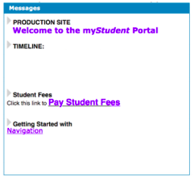
Activate your Parent Portal Account by selecting “Activate Account” on the screen. Enter the email address associated with your myStudent account and select “Send Email” which generates an email to activate the account. Go to your email and select the link. Continue by creating your password. Once this is completed, you will be able to see the school fees.

Step 3: After paying fees, return to the myStudent home screen. Complete the steps below to view the student schedule.

1. Open the “My Child Tab” on the left side of the screen.

2. Open the “Class Schedule” tab in the box that opens to the right.

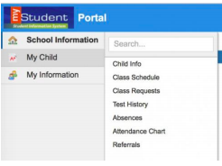

The classes listed are the current schedule for your child. These courses are connected to the fees that have been paid in Step 2. There is a way to print the schedule at the bottom of the screen. Note: Schedules could change prior to the start of the school year as we balance and level classes. We are not entertaining schedule change requests during the orientation day. We have created a separate system to communicate requests to the assistant principals for IB and for each grade level. You can access the form using the link below.

SCHEDULE CHANGE REQUEST

You have completed the virtual orientation for the 2019 – 2020 school year. Schedules will be printed out and distributed to students on the first day of school. Click on the link below for a map of the school. An alphabetical list of students with their first period teacher and room number will be posted throughout the school on Monday, August 12.

