Portal Page

Once a login is created, you will be signed in to Portal. Parents are able to view useful notifications and information related to their child, including real-time alerts and messages through their Portal Page.
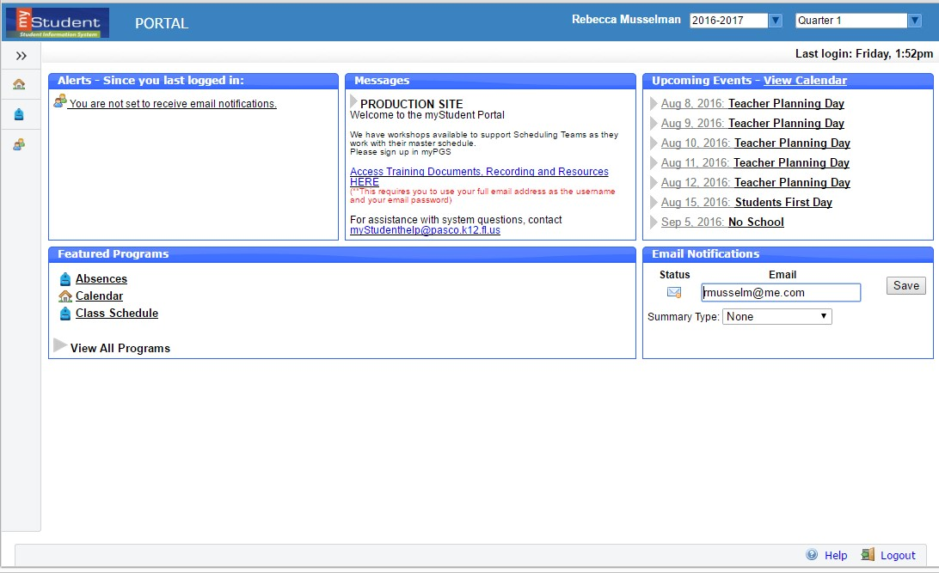

14

13

12

11

10

9

8

1

User Name Appears Here

2

6

4

School Name

3

7

1. myStudent Logo– Click on the logo to return to the portal page 2. User Name – Displays your first and last name.
- School Name – automatically switch to name the school your child is at.
- School year pull-down –Navigates between the current year and prior/future years.
- Child box- Parents with multiple students in the district can switch between their children by using this dropdown.
- Marking Period pull-down – Displays a list of available marking periods during the school year. Defaults to the currently active marking period.
- Main Menu- Drop down menus that allows users to navigate to different screens within Focus. This can expand or be minimized by clicking on the double arrows at the top.
- Alerts-These are any alerts specific to the user’s child such as: Absences, Referrals, or Unpaid Fees. These alerts are quick links and will take the user to more information about the subject.
- Messages- Messages by the user’s child’s school or district.
- Upcoming Events-District/school calendar of upcoming events the user can click on the View Calendar link to view the school’s calendar for the entire year.
- Featured Programs-Lists the user’s child’s/children’s classes along with their current grade for secondary schools.
Clicking the course or grade links will take the user to the Assignments & Grades screen for the student’s class.
- Email Notifications- Set up Email Notifications to keep up with your child(ren)’s portal information.
- Help- Provides Contextual help for open page, links to Focus University, can be opened in a new window, allows users to sign up for a Focus University account and receive email notices
- Logout- Closes the myStudent application, the system will time-out after 24 minutes of inactivity

My Child Menu

The myStudent Parent Portal is a tool designed to enhance parent’s access to their child’s education. Parents can review their student’s information, course history, graduation requirements, attendance and more. The My Child menu shows each of the pieces the user, as the parent, can access.

The following section reviews the My Child menu options:
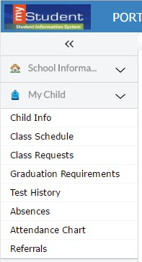

Child Info
The Child Info screen lists demographic information regarding the user’s child. Parents can review any of the information for accuracy and contact the school if changes should be made. Select a child from the top menu (if the user has multiple children).
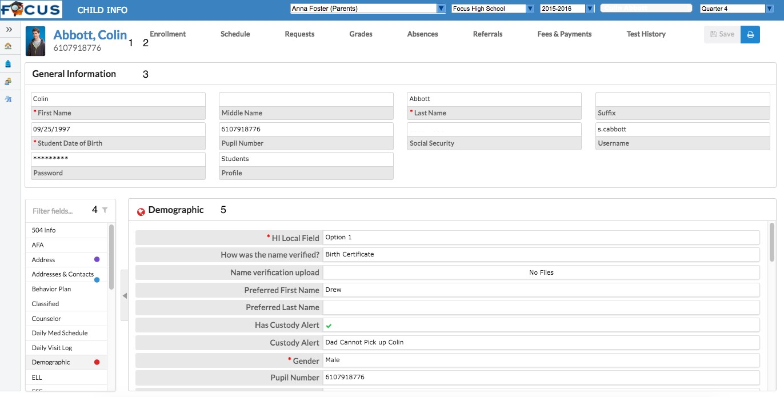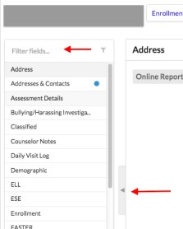

- This is the student’s name. By clicking on the name, a box will appear with the General Information of the student.
- Click on the tabs across the top to view Student information. See below for more information.
- This General Information area can collapse by clicking on the student’s name.
- The demographic menu allows the user to view demographic information for the student. The Filter Fields box can be used to search for a specific screen. The user can click the arrow to close the list of screens and expand the student information section of the screen.
Note: Clicking on the arrow will reopen the list of screens.
- The main screen will display the information/screen selected.
Enrollment
The Enrollment Sub-menu displays the student’s enrollment records, Rolling/Retention option, and Graduation Requirement Program. The chart layout (default view) allows users to scroll horizontally. Clicking Return to Enrollment returns users to the horizontal chart view.
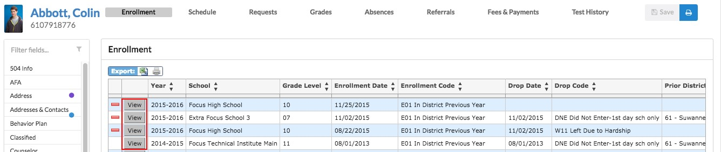

By clicking on View, the user will be able to view the details of the enrollment.
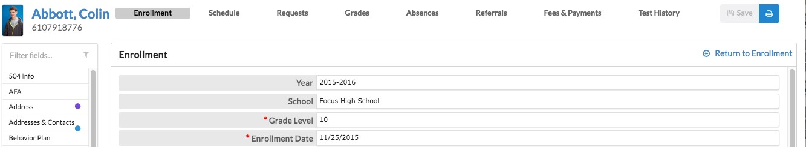

Schedule

The Schedule Sub-menu displays the student’s current schedule.
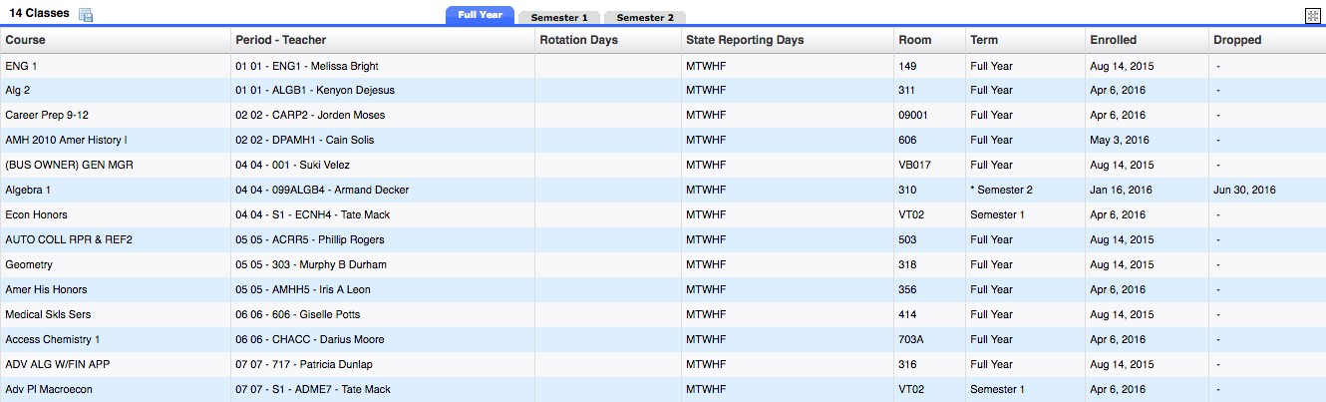

Requests
The Requests Sub-menu allows a user to view a student’s request. Requests are typically used for grades 6-12.
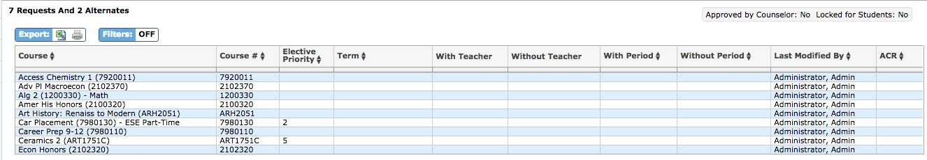

Grades

The Grades Sub-menu allows users to view a student’s grade history, final grades, GPA, and class rank. Grade information can be viewed by marking periods, semesters, year, or full academic history.
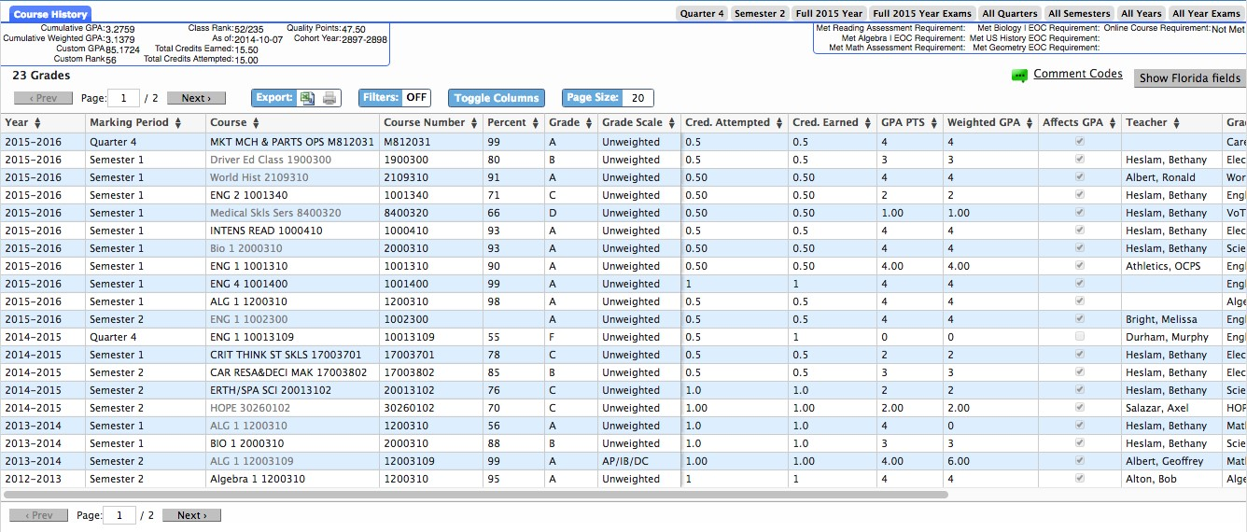

Absences

The Absences Sub-menu displays an Absence Summary of the student’s attendance. Users can view the data in a specified timeframe.
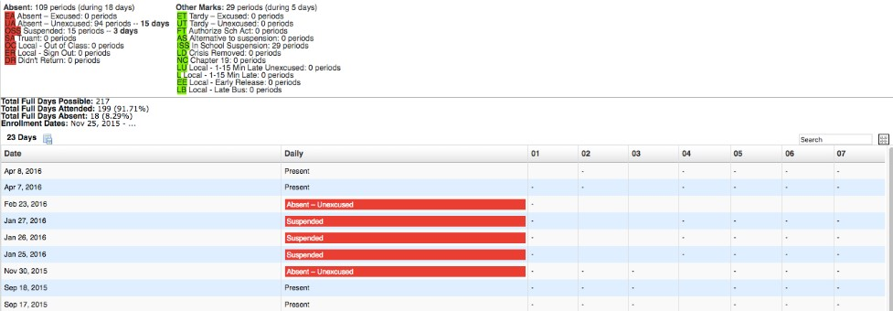

Referrals
The Referrals Sub-menu allows users to view a list of referrals the student has received. A user can also opt to view referrals from other schools the student has attended, as well as previous year referrals on the student.
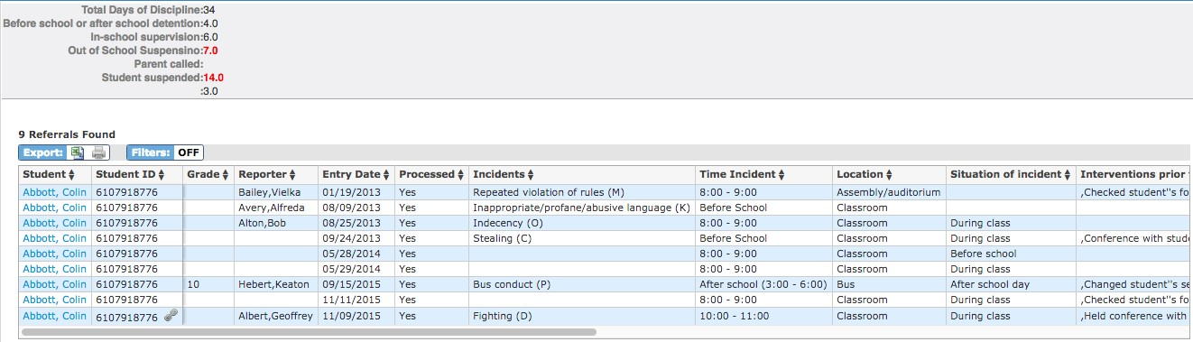

By clicking on the student name next to the referral that needs to be viewed, it will open the referral form to view.
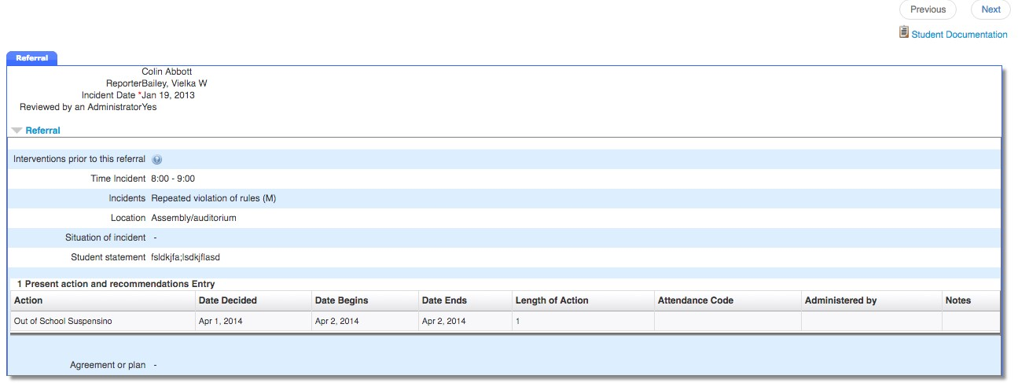

Test History

The Test History Sub-menu displays a list of all imported tests the student has taken. It also displays the administration date, the school year, and grade level for each test.
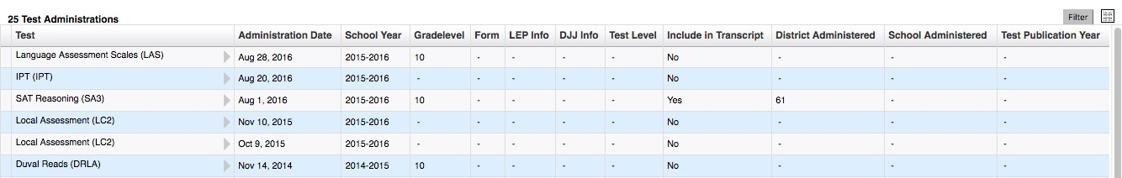

My Information MENU

From the My Information menu, Parents can change passwords, configure preferences for language, notifications and more.

My Profile
Allows you to view information about themselves to verify that everything is correct.

Preferences
Allows you to edit personal preferences.
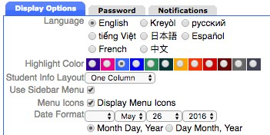

- Display Options Tab
Allows you to change the language, menu locations, color, and date format of the focus portal.

- Password Tab
Allows you to change their user password.
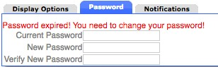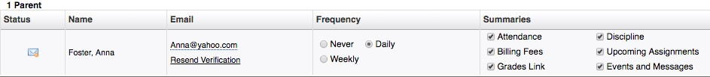

▪

Notifications

Allows the
user

to set the notifications they want to receive.

If Custom is selected, there are options to set thresholds for when notifications are sent about grades, attendance and discipline.
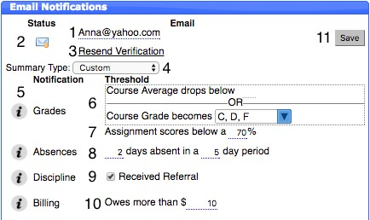

10

  - The email that will receive notifications. This can be changed by clicking on it.
  - Once a verification email is sent, parents can check the status of the verification.
  - Parents can resend the verification if needed.
  - Parents can decide how often they would like to receive notifications.

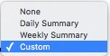

5.

Hovering or clicking on the

will give the use
r instructions.

#6 and #7  Viewable for  Secondary  Students ONLY | - Receive a notification if the Course Average or Grade gets below the specified amount.  - Receive a notification if the assignment scores go below the specified amount.  - Receive a notification if the student is absent for the specified number of days or more.  - Receive a notification if the student receives a referral.  - Click SAVE to ensure all changes are saved.

Assignments & Grades (SECONDARY Students ONLY)

The myStudent Parent Portal is a tool designed to enhance parent’s access to their child’s education. The portal allows parents to monitor their child’s progress in school by providing timely access to both assignments and grades that are entered by the teacher throughout the school year.

The Assignments & Grades menu allows parents to view their student’s grades for each class. The Assignments & Grades menu lists all the classes your child in enrolled in.
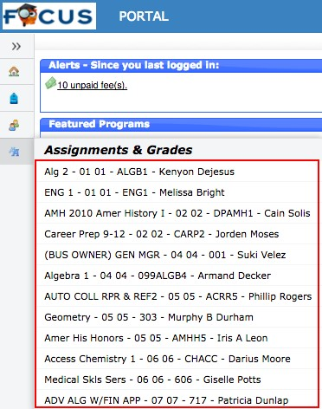

…or by
clicking on the class name or grade link

in the
Featured Programs

block:

Once the user selects a class, a detailed view of your child’s performance appears. From this screen, the parent can see a detailed breakdown of the classroom assignments. Listed at the top of the screen is a breakdown of the classroom assignment categories and their percentage towards final grade. Under the Percent of Grade, your child’s score in each category is listed. The assignments section lists all of the tests, classwork, homework, projects etc. for the class. Each assignment’s grade, possible points, assigned dates, due date, teacher comments and related files are viewable.
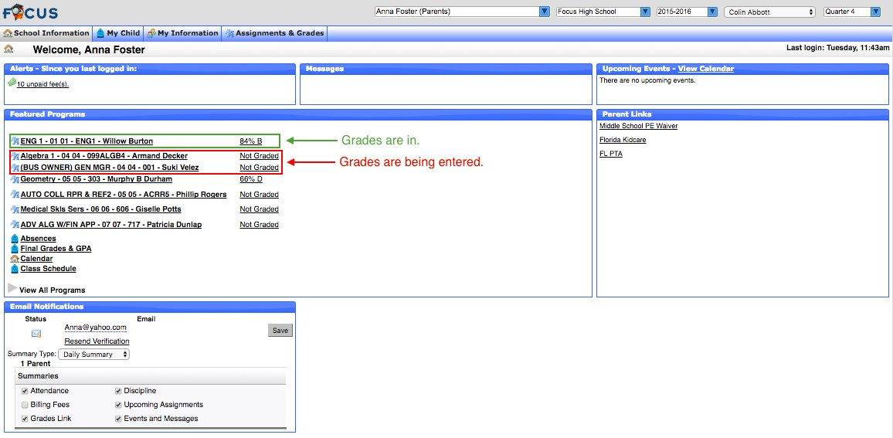

Viewing Final Grades (ELEMENTARY and SECONDARY Students)

At the end of a marking period, parents can log in to see final grades. These are updated throughout the marking period. Once the marking period is over, parents will notice the grades will reset to “Not Graded.”

FREQUENTLY ASKED QUESTIONS:

- WHO SHOULD USE myStudent Parent Portal?
myStudent Parent Portal is available to all parents or guardians of Pasco County School District for students PK-12.
- HOW TO I CREATE AN ACCOUNT?
Please contact your student’s school to receive log-in information or visit the Pasco County Schools Website and select the Parents link. If you have students in multiple grade levels or schools, you only need to contact one school. The myStudent Parent Portal will link families automatically.
- WHAT HAPPENS WHEN MY CHILD MOVES TO ANOTHER SCHOOL?
myStudent Parent Portal accounts roll over from year to year, so when your child moves from middle to high school, you do not have to create a new account. Also, if your student moves to another school within Pasco County, your account will be updated with the new school information. • I CAN’T REMEMBER MY PASSWORD?
If you have forgotten your username or password, please reset the password from the entry screen. You will be emailed with a replacement password that you can use to login, then reset the password to a selection of your choice after re-entry.
- HAVING PROBLEMS?
If you are experiencing problems with logging in, or navigating the site or if you have a question about your student’s information, such as grades, attendance, discipline, or addresses and contacts, please contact your student’s school.

Student Portal

The student portal page is similar to what teachers see, with a few differing links. The myStudent Student Portal will display (alert) upcoming events and assignments to help students stay organized. In addition to reviewing important information including current grades, GPA, and attendance students can email their teachers directly from the Portal.
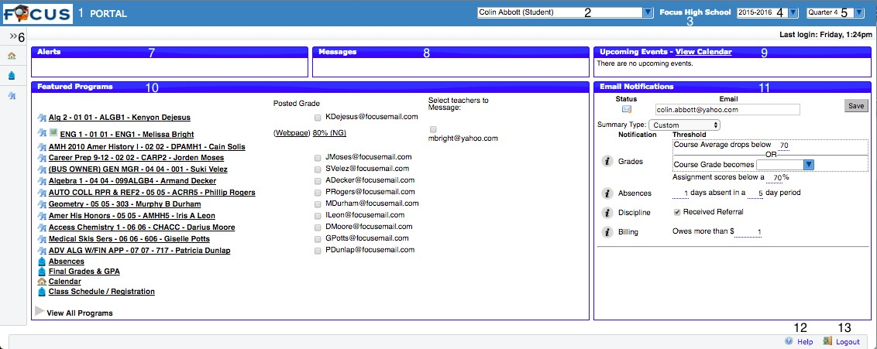

Some notable features:
- Click the myStudent Logo in the top left corner from any screen to return to the main Portal Page.
- This area display’s the student’s name.
- This is the school the student is registered at.
- School Year Pull-Down: Students can access information from past and current school years. When the student is in any year other than the current year, the menu background turns from grey to blue.
- Marking Period Pull-Down: Students can select a specific grading period to view information.
- Menu: students can access all features of myStudent within the Menu options.
- Alerts: upcoming assignments will be displayed.
- Messages: contain reminders from the school.
- Upcoming Events - Calendar: provides a direct link to the 30-day school calendar; displays the next seven calendar events set by the school. Click on Event Name or View Calendar to see details.
- Featured Programs: Specific links (shortcuts) to features used most often. Clicking a course link will bring the student to Assignments & Grades for a specific course at the SECONDARY level ONLY. Other links will direct students to specific information about absences, GPA, etc.
- Email Notifications: Allows students to setup email notifications for their grades, absences, and discipline.
- Help- Provides Contextual help for open page, Links to Focus University, can be opened in a new window, allows users to sign up for a Focus University account and receive email notices
- Logout- Closes the myStudent application, myStudent time-out is after 24 minutes of inactivity

My Information
Students will have access to their own demographic information, course history, schedule, and grades as well. From the My Information Menu, the student can access a wealth of information applicable to their coursework, current schedule, and any existing student records housed in myStudent.
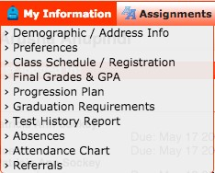

Assignments & Grades
Secondary students can access the gradebook for each course from the course links on the portal page or by using the Assignments & Grades Menu and selecting a course. Upon selecting a course, the student will see a breakdown of all the assignments from the gradebook, the score received on each assignment, whether it has been graded or not, and any comments that have been made public by the teacher for any of the assignments.
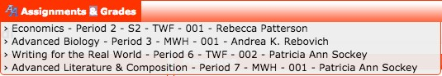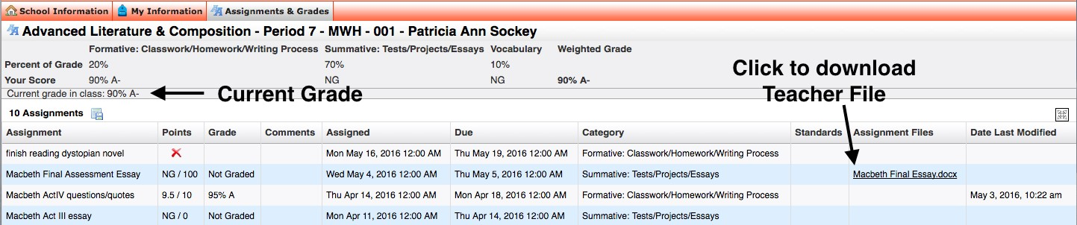

School Information & View Calendar

Students can access School Information to look at upcoming school wide events and individual assignments by selecting Calendar and/or View Calendar.
